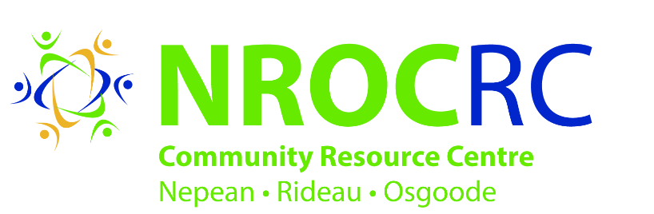

Program Facilitator

Position Type: Part time, contract, 2 hours per week

Employment period: January 21, 2019 – November 29, 2019

Salary: $18 an hour

Job Area: Nepean

SCOPE OF POSITION:

The program Facilitator will be part of a multi-disciplinary team that is responsible for facilitating the deliverables of the Community Development initiatives in Tanglewood. These responsibilities will include, but may not be limited to: facilitating monthly community engagement activities, hosting workshops, procuring program supplies and tracking attendance and program data. This position requires someone who can work across a variety of different demographic groups.The successful candidate must commit to work within NROCRC’s model of Community Development.

JOB SPECIFIC RESPONSIBILITIES:

- Implement a strength-based, resident-focused approach that builds on the collective assets of the Tanglewood community
- Work with community groups, Tanglewood Community Association and local businesses to support communication between community partners and residents
- Promote community engagement events and activities and connect with potential volunteers in the community
- Coordinate meetings with community residents and volunteers to plan and organize events in Tanglewood
- Establishing rapport and building trust with a strong focus on developing relationships with Tanglewood residents
- Preparing and maintaining all necessary documentation and statistics related to all activities on a monthly and quarterly basis
- Perform other duties as assigned by the supervisor
- Must be computer literate

QUALIFICATIONS - EDUCATION / EXPERIENCE

- Degree or Diploma in social Work or equivalent combination of education and experience
- Experience in facilitating programs and delivering workshops in the community
- Excellent communication and interpersonal skills and demonstrated ability to work with diverse groups.
- Strong outreaching and promotion skills
- Experience working within a multi-disciplinary team.
- Strong organizational and time management skills
- A valid driver’s license and use of car is required.
- Fluency in English is essential. (Other languages are considered an asset)
- Ability to work flexible hours.
- Police records check is required
- Preference will be given to Tanglewood Community members

Please submit your cover letter and resume by January 14, 2019

Reply to: Janet Donovan
By email: Jdonovan@nrocrc.org

We would like to thank all candidates for applying; however only those selected for an interview will be contacted directly. Due to the high volumes of interested applicants, we will not be able to receive phone calls asking for more information on available positions.

NROCRC is an equal opportunity employer committed to building a diverse work team representative of the community we serve.

NROCRC welcomes applications from people with disabilities. Accommodations are available on request for candidates taking part in all aspects of the selection process.

